**Christianity: Reflecting on the *Our Father* Prayer** *These resources are designed for school-aged children, please use the activities as a menu and select the ones that best suit your child.*

 **Introduction**

Thy Kingdom Come is a Christian Prayer initiate that happens every year between Ascension and Pentecost. In this time Jesus’ followers: had encountered him as a resurrected person, witnessed him ascending to heaven, had hidden and prayed together in the upper room and then had a transformative supernatural encounter with the Holy Spirit at Pentecost which is often called the birthday of the church.

This year *Thy Kingdom Come* happens between May 21-31st 2020 and the activities we have created are for you to learn more about this important part of the Christian story, looking at some big ideas. These include:

* What kind of king is Jesus?
* How do Christians think the world should be cared for?
* How do you think the world should be cared for?
* What do Christians mean when they pray ‘Thy will be done’?
* And how do Christians know what God’s will is?
* How can we understand what Christians mean when they say God is their saviour?
* Is God a help to believers in times of trouble?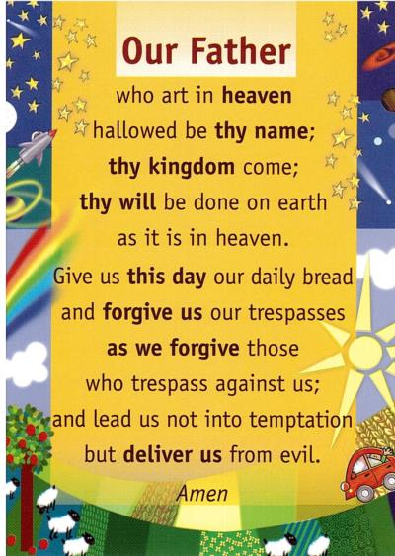
* Why is Pentecost called the birthday of the church?
* Why is the Holy Spirit so important to Christians?

The words ‘Thy Kingdom come’ are in the Lord’s Prayer which can be found in the bible in Matthew 6:5-15; Luke 11:1-13. In the story Christians are told that these are the words Jesus told his followers to use when they prayed. As a result the *Our Father* is the most known and used prayer in the Christian faith. You may know it but have you ever thought what it means?

**What kind of King is Jesus?  
How do Christians think the world should be cared for?**

**How do you think the world should be cared for?**

Christians believe that in the Bible they can find out about God and what he wants the world to be like. The Bible is made up of lots of different books, the first book of the Bible is called Genesis. Christians believe that God made the world and everything in it, Genesis tells the story of how this happens. Some of you might have found out about the different interpretations that different Christians have about Genesis chapter one. Chapter one tells Christians that: ‘God saw what he had made and it was good’. I wonder how would you describe a perfect world? You might like to create a wordle of adjectives to describe a perfect world.

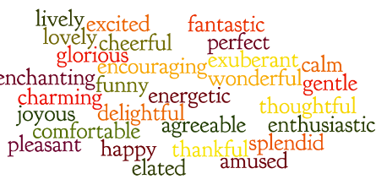

**Making your own Wordle**

You could use this link to make an electronic wordle…

<http://www.wordle.net/create>

**What do Christians believe God wanted the world to be like?**

In Genesis 1 it says:

***Then God said, “I give you every seed-bearing plant on the face of the whole earth and every tree that has fruit with seed in it. They will be yours for food. 30And to all the beasts of the earth and all the birds in the sky and all the creatures that move along the ground—everything that has the breath of life in it—I give every green plant for food.” And it was so.***

***31God saw all that he had made, and it was very good. And there was evening, and there was morning—the sixth day.***

What do you think God wanted to world to be like? How do you think God wanted the world to be cared for? Fill in the table below, try to list what you think God wanted the world to be like and what the world is like today.

|  |  |
| --- | --- |
| **How do you think God wanted the world to be cared for?** | **How is the world cared for today? What is the world like today?** |
|  |  |

Looking at your lists; do you think that Christians believe that God’s world is cared for in the right way today? How might a Christian want to change the way the world is cared for.

**What in the world might people want to say thank you for?**

Look at some pictures of the world that we live in, you might like to use the National Geographic website (<https://www.nationalgeographic.com/photo-galleries/>). While you are looking at the pictures, think carefully about what you might like to say thank you for. Are there any pictures that make you feel sad?

Christians say thank you to God for the things that he has made in the world. One of the key features of prayers that Christians say is a thank-you. What in the world would you say thank you for? Who would you thank for the beautiful things in the world?

**Pause to Reflect: Going Outside – Saying a sticky thank-you**

There are lots of beautiful things in the world around us, some of these things can be found in our gardens or in the spaces around our houses. Some people see beautiful things while they are out for a walk or taking some exercise. We are going to think about the beautiful things that are found around the places that we live.

1. You will need to find a strip of card (you could use a cut-out strip of card from a cereal packet).
2. Cover one side of the card with double sided tape, go outside into your garden and cover your tape with anything that you think is beautiful (remember to only pick up things that have fallen to the ground, don’t pick leaves or flowers from where they are growing).
3. When you have finished you might like to think about who you think created these beautiful things and who you would say thank you to for them.

Christians believe that God created everything and everything comes from God. How do you think a Christian might say thank you for the things that they see and find around the place that they live?

**What other features of prayer are there?**

When Christians are learning to pray, sometimes they use the teaspoon prayer to help them to remember the key features or parts of a prayer.



Christians try to say prayers that include a thank you, a sorry and a please. This is based on the Lord’s prayer that Jesus taught his followers to pray. A teaspoon (tsp) prayer might look like this.

Father God,

Thank you for the beautiful world that you have given us.

Sorry that we don’t always care for the world in the way that you would want us to.

Please help us to be better carers for the world.

Amen

**Can you spot the features of the ‘teaspoon prayer’?**

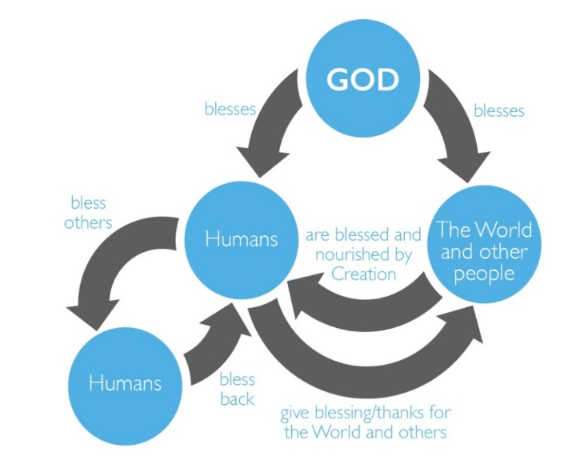**What do Christians mean when they pray’ Thy will be done’?**

We have just learned about what kind of king Christians believe Jesus is and how his kingdom is a place where love is at the heart  of all God is and does.

Christians believe that because they are loved by God they should: love God back, love themselves, others and the world. It’s as Christians start to see the world through God’s eyes and want to respond to it in the way he would want them to.

**What do Christians mean by Love?**   
In the Bible in 1 Corinthians 13 Christians are told: Love never gives up. Love cares more for others than for self. Love doesn’t want what it doesn’t have. Love doesn’t strut; doesn’t have a swelled head; doesn’t force itself on others; isn’t always “me first”; doesn’t fly off the handle; doesn’t keep score of the sins of others; doesn’t revel when others grovel; takes pleasure in the flowering of truth; puts up with anything; trusts God always; always looks for the best; never looks back; but keeps going to the end. Love never dies.

Take some time to read this and think about the bits that mean something to you.

Imagine wearing some special glasses that would enable you to do this? What things might you notice in the world that reflect love? What things do you think show people being unloving, to themselves, others and creation? If you want you could make some sunglasses for yourselves. You could design your oen or use this template: <https://picklebums.com/images/printables/picklebums_crazyglasses.pdf>

**Pause to Reflect**

Is there something I can do to be more loving to myself, others in my home or further away? How can I show my love for creation? What might I do today? This week?

**Thinking about feelings**

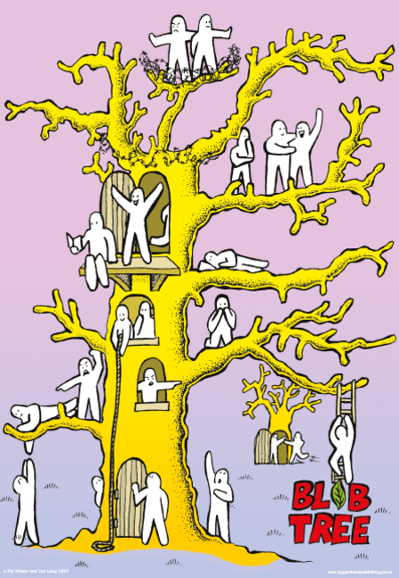Sometimes life is great and sometimes life is hard. Sometimes it can be both at the same time. That is true for all of us.

Have a look at this blob tree and use it to help you describe how you are feeling. Which blob people do you identify with? Which one shows the way that you are feeling?

Christians believe that because Jesus was a person and God at the same time (you may have heard of the word incarnation) and that God understands what it like to feel the whole range of emotions.

For Christians prayer is coming to God as they are and letting God’s love into the things that they are facing. It is about being real (authentic) and not pretending things aren’t great when they are not. Jesus was given lots of names one of them is Emmanuel which means ‘God is with us.’ Christians believe that God is with them all the time.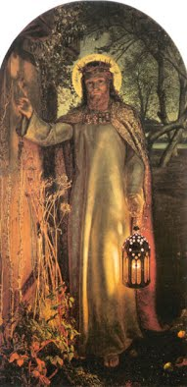 There is a very famous painting by the Victorian-era English artist William Holman Hunt called ‘the Light of the world’ which he painted in 1853. You can find it in St Paul’s Cathedral in London. If you look closely you will see Jesus is knocking on a door. If you look even closer you will notice there isn’t a door handle on his side of the door. Christians believe that God knocks on the door of everyone and that we have a choice as to whether we let him in. When a person prays it is like they are opening the door of their hearts and lives and letting God in to be with them.

**Pause to Reflect**

Using your fingers to count how many different ideas about Christian prayer can you come up with? Have any of these changed?

Watch this film clip of people talking about prayer <https://www.bbc.co.uk/teach/class-clips-video/religious-studies-ks2-christian-prayer/zbjv92p> and see if there is anything else you have learned.

**How can we understand what Christians mean when they say God is their saviour?  
Is God a help in times of trouble?**

Have you ever felt worried or afraid about something? What did you do with that worry or fear? Some people have worry dolls or a worry monster that they share their worries with.



What kind of things might people write down to feed the worry monster with? What might you share with the worry monster?

You might choose to make your own worry monster to keep at home.

In the Bible it says ‘cast all your anxiety on to him because he cares for you.’ (1 Peter5:7). Christians believe that they should share their worries with God through prayer. How do you think this might be helpful for them when they are feeling worried or afraid?



**Praying ‘Thy will be done’**  
Part of the Lord’s prayer says ‘Thy will be done’. This means that the person praying the prayer is saying that they want God’s will to be done in all situations. What kind of situations might they pray ‘thy will be done’ in? Can you make a list of times when a Christian might choose to pray these words?

Christians believe that God wants them to pray ‘thy will be done’ in all situations. Can you think of a time when praying this might be hard?

**Pause to reflect**  
Imagine that a young girl called Anna has a Grandma who is ill in hospital. The doctors are very worried about Anna’s Grandma and Anna is desperate for them to make her better. Anna’s mum and dad are very worried about Grandma too. Anna and her family are Christians. Why might it be easy for them to pray ‘thy will be done’? Why might it be hard for them to pray this? Do you think that Christians think that death isn’t the end would make a difference to how Anna and her family feel about the situation?

**Getting answers from God**  
Christians believe that it is really important to pray to God about everything. We looked earlier at teaspoon prayers (tsp) which feature a: thank you, sorry and please. Christians believe that God always answers their prayers but sometimes the answer they get is not always the one that they want. They think that sometimes God says ‘yes’, sometimes he says ‘no’ and sometimes he says ‘not yet’. Why might it be hard to have an answer to prayer that is a no or a not yet? In the Bible it says that God has a plan for everyone’s lives, God calls Christians to trust in his plan, sometimes this is hard for them and sometimes it is easy. Why do you think trust in God would be easy? Why might it be hard?

**Why is Pentecost called the birthday of the church?**

To start these reflections you might want to watch these two short film clips <https://youtu.be/OMQKy1Mx49M>

<https://youtu.be/vuUK6REOWuE>

Make a list of the key things you remember that were the same in each clip and of things that were different.

|  |  |
| --- | --- |
| **Same** | **Different** |
| 1 2 3 4 5 6 7 8 | 1 2 3 4 5  6 7 8 |

**Pentecost – The birthday of the Church**Christians think of Pentecost as the birthday of the church because that is the day that Peter, empowered by the Holy Spirit, spoke to the crowd and thousands of people decided to follow Jesus.

To remind yourself that Christians think of Pentecost as the birthday of the church you could make a microwave mug ‘birthday’ cake using the recipe on this page <https://exeter.anglican.org/resources/faith-action/family-fun-cooking-club/>

**Pause to Reflect**Shut your eyes and try to imagine you were in the upper room on the Day of Pentecost what do you think it would have felt like for Jesus’ disciples to have experienced the Holy Spirit for the first time. **What is so important about the Holy Spirit? What difference does it make to Christians?**

To really understand the Holy Spirit we need to go back and understand its significance over time and this film clip gives you a lot more information to think about.

<https://youtu.be/oNNZO9i1Gjc>

How would you describe what Christians understand by the Holy Spirit?

***God’s presence ruakh energy influence sustaining Life empowering for specific tasks transform new creation creating life***

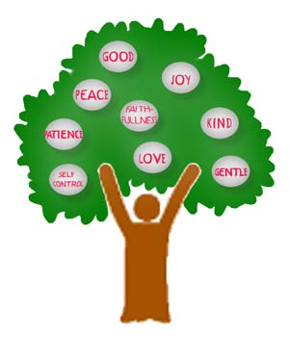For Christians Pentecost was important then and is important now. Just as the Holy Spirit transformed the Jesus’ followers Christians believe the Holy Spirit equips them now. For Christians a sign that the Holy Spirit is at work in their lives is that there are noticeable signs of change or ‘fruit of the Holy Spirit’.

Sometimes it’s easy to feel these good feelings but Christians believe that when things are tough the Holy Spirit can give them what they need to experience things supernaturally. For example they might feel a great sense of peace even when they are facing something challenging because they know God is with them.

A bit like a tree has roots Christians talk about being ‘rooted in God’. Trees get many of the things they need to thrive through their roots. In the same way Christians believe being with God (prayer) helps them to thrive.

**Pause to Reflect**

What new things have you learned about the Holy Spirit? Christians believe the Holy Spirit is part of the Holy Trinity and God. What do you think Christians believe the Holy Spirit tells us God is like? Does this raise any other questions for you? You could email your questions to a Christian believer by using the following link <https://www.reonline.org.uk/christian-email-a-believer-resources/>