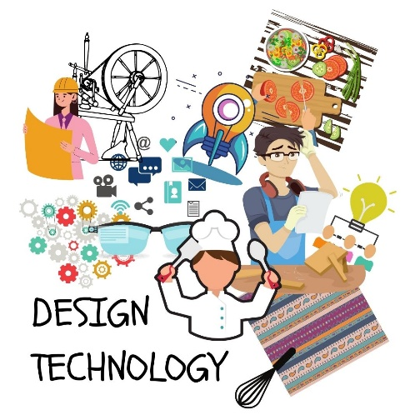
Design and Technology

Here at Bickleigh Down, we aim provide all children with a broad and balanced curriculum which prepares them for life beyond primary education. We encourage children to learn, to think and to work creatively to solve problems; both as individuals and collaboratively as members of a team.
Creativity and imagination are greatly encouraged at Bickleigh Down, as they allow the children to design and make products that solve real and relevant problems within a variety of contexts, considering their own and others’ needs, wants and values. Where possible, we encourage children to make connections to other subjects, such as Mathematics, Science, Computing, Topic and Art. The children are also given opportunities to reflect upon and evaluate past and present technology and its usefulness

We aim to ensure that through high quality of teaching a variety of creative and practical activities, we teach the knowledge, understanding and skills needed to engage in the process of designing and making. Using a clear learning journey, children are able to show the clear process of researching, designing, making, improving and evaluating which are skills they can take through into later life.

A designer from Bickleigh Down will be able to:

- Have confidence in design and technology that they will then apply to other areas of the curriculum.
- Ultimately know more, remember more and understand more about Design Technology, demonstrating this knowledge when using tools or skills in other areas of the curriculum and in opportunities out of school
- Achieve age related expectations in Design Technology.
- Develop skills and attributes they can use beyond school and into adulthood.


